EMBROIDERY ORDER FORM
Please complete and email to: info@budomartamerica.com
BELTS
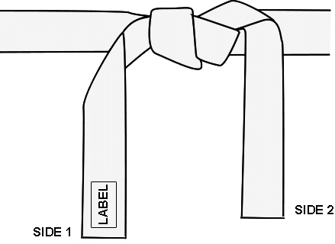
Date:1/3/2019
Name: __________ ______________
Belt Model : Choose an item.
Belt Label : Choose an item.
Belt Color : Choose an item.
Belt Length: Choose an item.

Embroidery Side 1: ___________ _____________________________
☐ Katakana ☐ Kanji ☐ English Text ☐ Dans (type ‘X’ for each Dan Bar) ☐ Other Choose an item.

Embroidery Size 2: ____________________ ____________________
☐ Katakana ☐ Kanji ☐ English Text ☐ Dans (type ‘X’ for each Dan Bar) ☐ Other Choose an item.

Embroidery Style: ☐ Horizontal ☐ Vertical ☐ Standard Embroidery ☐ Butterfly Style
Standard Style
Stitching will show on back side of the belt. Available cotton & satin belts.
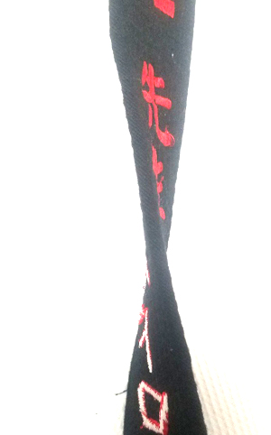
Butterfly Style
Stitching does not show on back side. Only available in cotton belts.
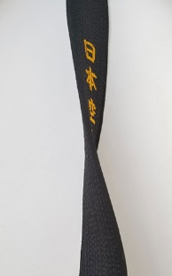
TEXT
TEXT

Embroidery Color Side 1: Choose an item.
Embroidery Color Side 2: Choose an item.
Comments:

*Once we receive your order, we will contact you with the embroidery quote
*Please allow 1 -2 weeks for all embroideries to be completed. Please give us a call at 562-941-2242 if you have any questions.

